
A CENTER FOR INTER-DISCIPLINARY RESEARCH
2020-21
TITLE

“MOVIES RECOMMENDATION SYSTEM”

SUPERVISED BY
Padmini Kousalya Madhira


GOKARAJU RANGARAJU
INSTITUTE OF ENGINEERING AND TECHNOLOGY AUTONOMOUS
Advanced Academic Center
( A Center For Inter-Disciplinary Research )
This is to certify that the project titled
“MOVIES RECOMMENDATION SYSTEM”
is a bonafide work carried out by the following students in partial fulfilment of the requirements for Advanced Academic Center intern, submitted to the chair, AAC during the academic year 2020-21.
NAME
ROLL NUMBER | SECTION
AREKELA ANJALI | 21241A04D5 | ECE
VAISHNAVI CHITNEEDI | 21241A6679 | CSM
PYGUSTI NOUSHEEN | 21241A0542 | CSE
TAGUDAM PRANEETH REDDY | 21241A0343 | MECH
THOTA KARTHIKEYA MANIKANTA | 21241A66J8 | CSM
Dr/Ms./Mr.
Dr.B.R.K.Reddy Dr.Ramamurthy Suri
Project Supervisor Program Coordinator Associate Dean,AAC


ACKNOWLEDGEMENTS
We express our deep sense of gratitude to our respected Director, Gokaraju Rangaraju Institute of Engineering and Technology, for the valuable guidance and for permitting us to carry out this project.
With immense pleasure, we extend our appreciation to our respected Principal, for permitting us to carry out this project.
We are thankful to the Associate Dean, Advanced Academic Centre, for providing us an appropriate environment required for the project completion.
We are grateful to our project supervisor who spared valuable time to influence us with their novel insights.
We are indebted to all the above mentioned people without whom we would not have concluded the project.
INDEX:
- Abstract
- Introduction
- Project workflow
- Code
- Future developments
- References
MOVIES RECOMMENDATION SYSTEM
Abstract
A Movie Recommendation system is a system that provides movie suggestions to users based on some dataset. Such a system will predict what movies a user will like based on the attributes of previously liked movies by that user. Content-Based recommendations have long been in fashion but they tend to overlook some great suggestions that may not be covered by mere cosine similarities. To overcome such shortcomings, we will combine collaborative filtering techniques having a User-User matrix with neural networks to provide users(who have already rated movies previously) with appropriate suggestions. We use cosine similarity algorithm to find similar movies based on our interest.
Introduction
Recommendation Systems have been in existence for a long time and have served towards convenience of people. In the most general way, recommender systems are algorithms aimed at suggesting relevant items to users(items being books to read, products to buy, music to listen or as in our case, movies to watch.) The most common approach towards recommendation systems has been the Content-based recommendations. Content-based techniques develop representations of clients and items through the investigation of additional data, for example, record content, client proles and the traits of items, to make suggestions .In many cases, the data that is utilized to build the pictures is difcult to get or even fake; subsequently, its presentation and application run experience the ill effects of signicant restrictions. Thus, we take another approach called as the Collaborative Filtering where instead of only depending upon the attributes of the item, we let our users rate different items and based on such ratings we make recommendations using two ways, either by User-User similarities or Item-Item Similarities. In User-User similarity approach, we let our users rate movies and then find other users who rated movies similarly to our test user i.e we find other users who feel similarly as our test user. On the other hand, an Item-Item approach includes letting our user rate items and then find other items that have similar ratings. Although this method is simple and effective, with the rapid development of the Internet, the high sparsity of the data limits the performance of the algorithm. To overcome it, we will combine collaborative filtering with Neural Networks We will use neural network embeddings to improve our model.
In this we are going to recommend movies based on content. This approach for recommending movies does not involve other users. Based on what we like, our algorithm will pick similar items i.e items having similar content and recommend us.
In this approach, the diversity in recommendations will be the least as it only takes into consideration what the user specifically likes. E.g, A user that says they like Action movies will only be recommended other action movies until they try some other genre autonomously and decide to give it a like. Ofcourse, there are many categories we can calculate the similarity on: as in our case of movies, we can decide to find similarity based on genre, keyword, cast,director and so on.
Algorithm used :
COSINE SIMILARITY
To find similar content for our item, we used the cosine similarity algorithm. The dot product between two vectors is equal to the projection of one of them on the other. Therefore the dot product of two identical vectors is equal to their squared modules. On the other hand if the two vectors do not share any directions, the product will be zero. General formula for calculating dot product is given below:
This dot product is important when defining the similarity as it is directly connected to it. The definition of similarity between two vectors u and v is in fact the ratio between their dot products and product of their magnitudes.
Thus, this will be equal to 1 if the two vectors are identical or it will be 0 if the two are orthogonal.

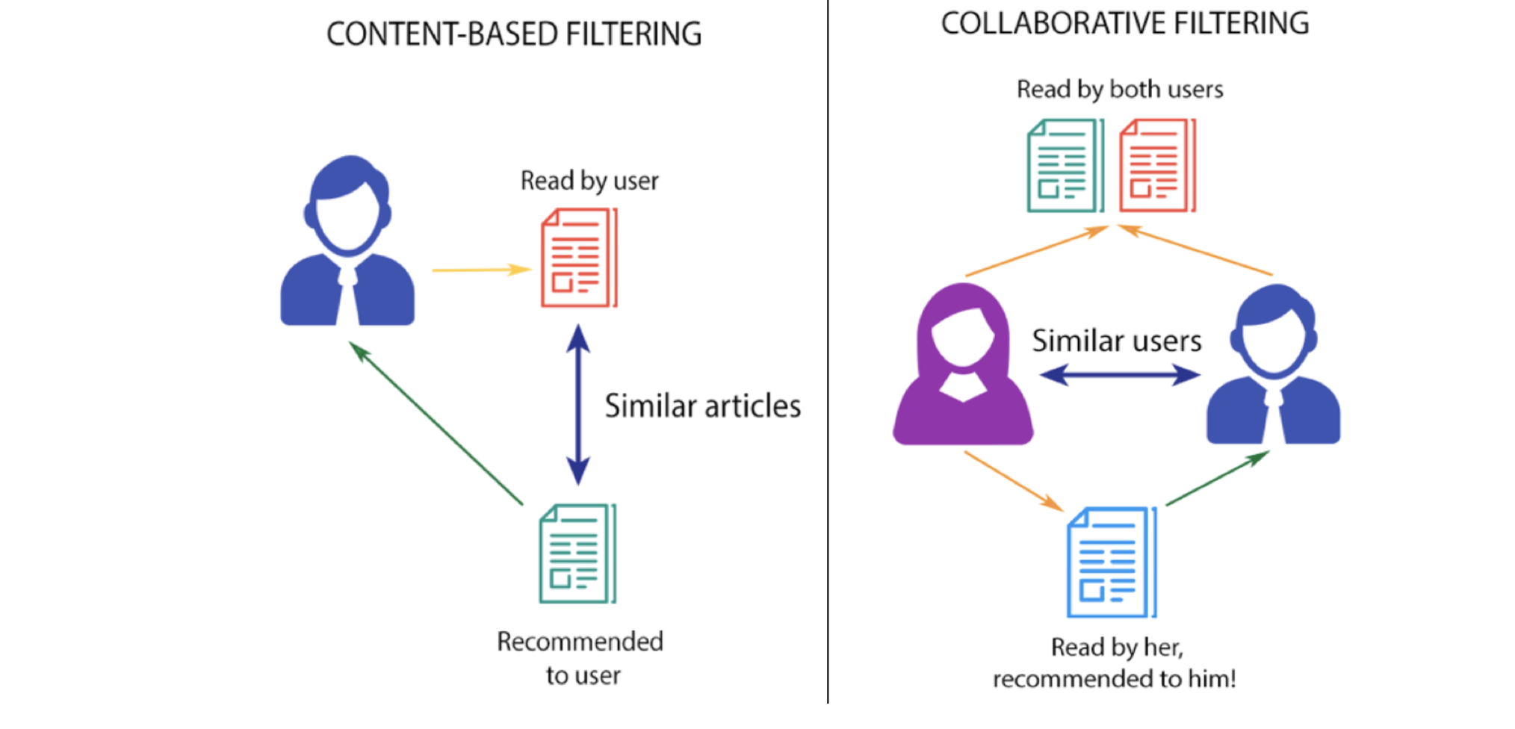
Project Workflow
In this implementation, when the user searches for a movie we will recommend the top 30 similar movies using our movie recommendation system. We will be using a content based collaborative filtering algorithm for our purpose.
In this we used a dataset consisting of 4809 movies and the following information about movies : budget, genres, homepage, id, title, overview, popularity, production, revenue, runtime, language, status, tagline, cast, crew, director.
- Make necessary inputs
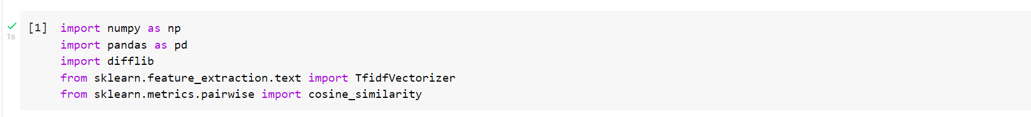
- Import dataset
- Print movies and shape of the dataset
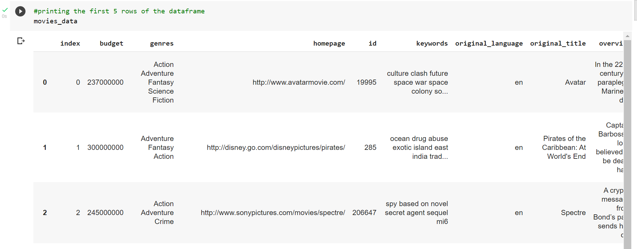
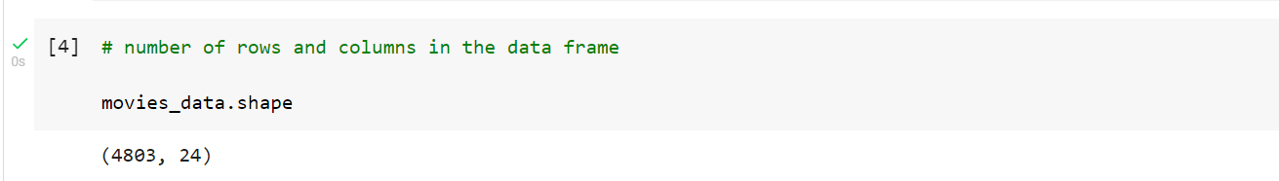

- Select the features from your dataset based on which you want to recommend your movies.
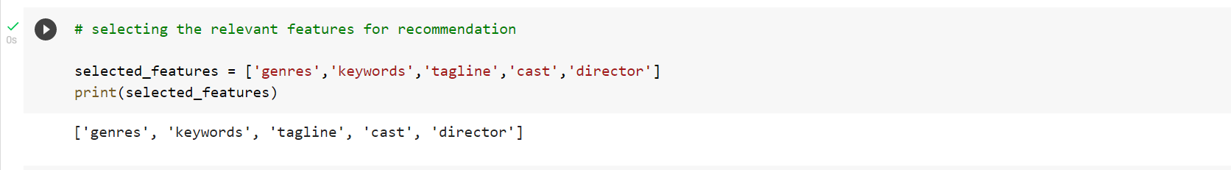
- Replace all the null values in the dataset with null strings
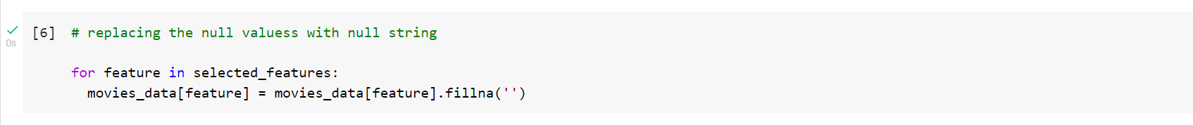
- Now modify the dataset by combining the selected featues
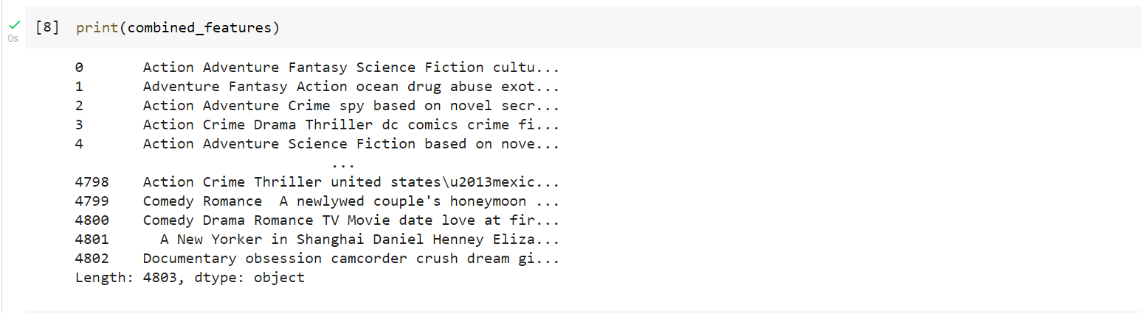
- Convert the text to vector form by using TfidfVectorizer
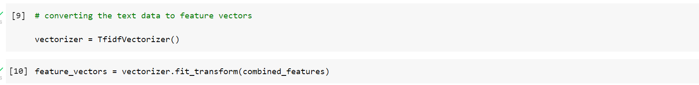
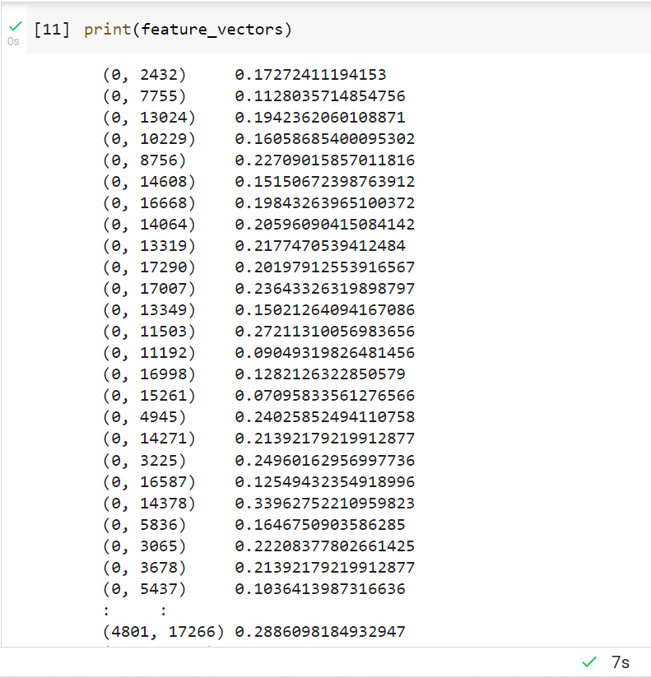
- Now use cosine similarity algorithm which generates a square matrix by comparing each movie with every other movie in the dataset
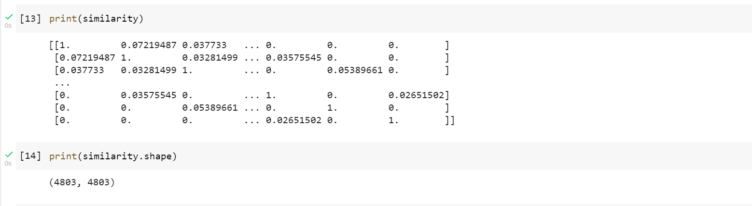

- Input movie name to find similarity between the movie with other movies
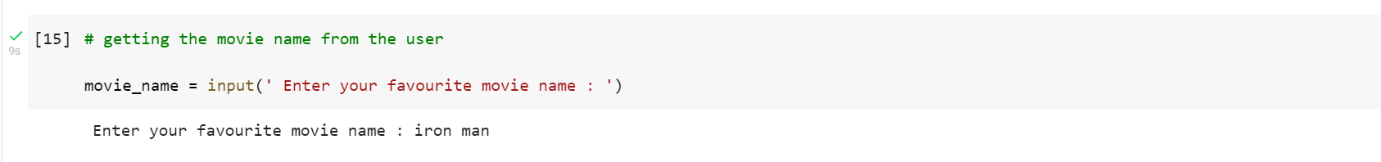
- Make a list of all titles
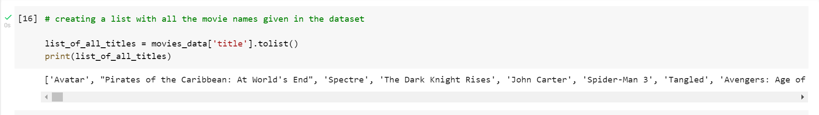
- Now find the close match from the tiltles list which matches input title by using difflib.
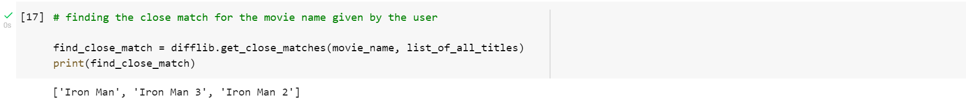
- Now get the index of the input movie
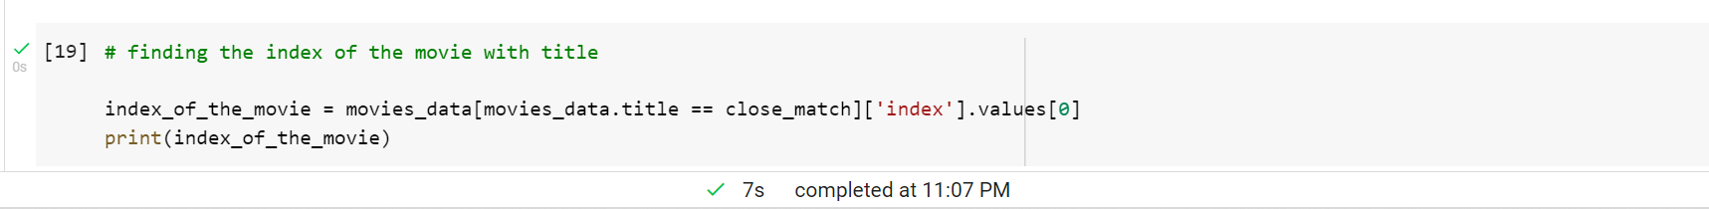
- Make a list of similarity score of all movies with the input movie
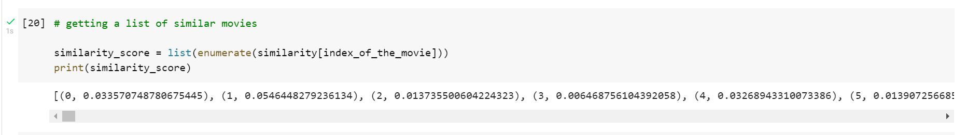

- Now arrange the similarity score in descending order
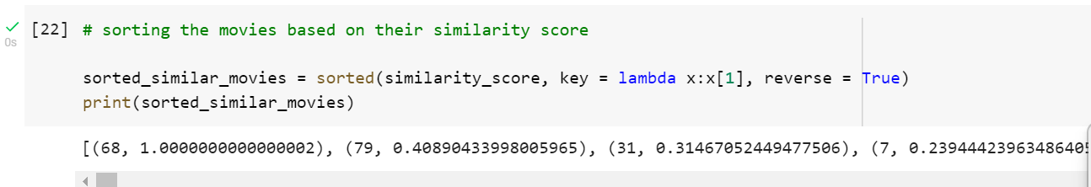
- Print the recommended movies for input movie
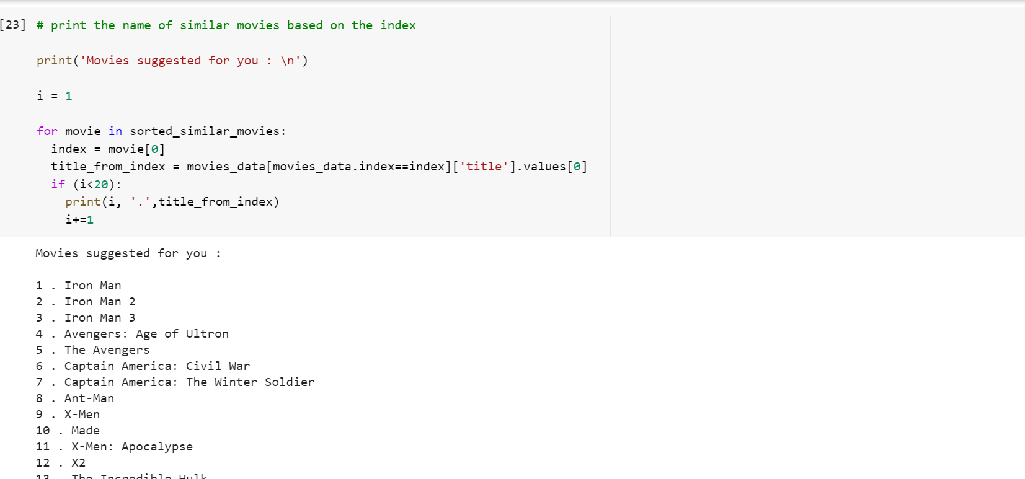
MOVIES RECOMMENDATION SYSTEM
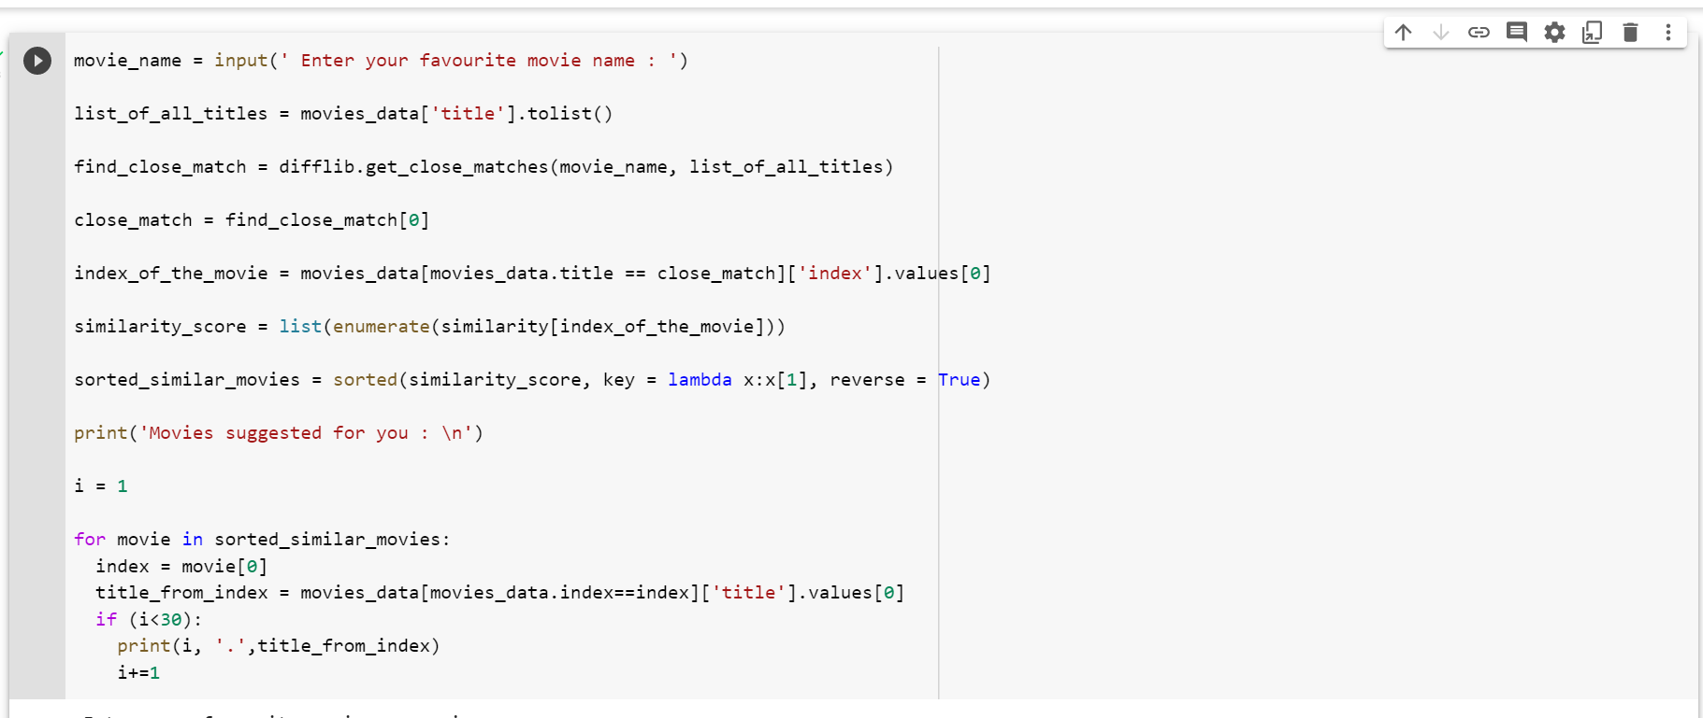

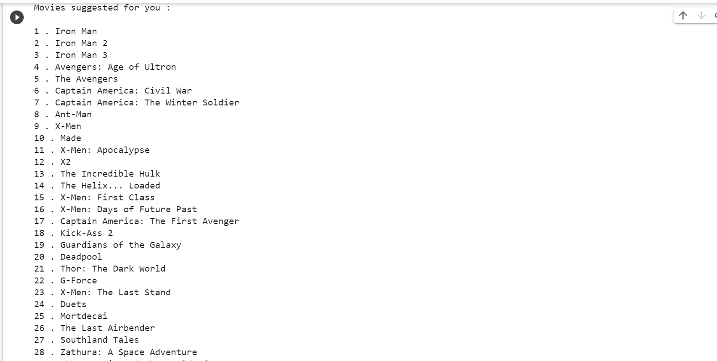

Code
import numpy as np
import pandas as pd
import difflib
from sklearn.feature_extraction.text import TfidfVectorizer
from sklearn.metrics.pairwise import cosine_similarity
#loading the file from csv file to apandas dataframe
movies_data = pd.read_csv('/content/movies.csv')
#printing the first 5 rows of the dataframe
movies_data
# number of rows and columns in the data frame
# selecting the relevant features for recommendation
selected_features = ['genres','keywords','tagline','cast','director']
print(selected_features)
movies_data.shape
# replacing the null valuess with null string
for feature in selected_features:
movies_data[feature] = movies_data[feature].fillna('')
# combining all the 5 selected features
combined_features = movies_data['genres']+' '+movies_data['keywords']+' '+movies_data['tagline']+' '+movies_data['cast']+' '+movies_data['director']
print(combined_features)
# converting the text data to feature vectors

vectorizer = TfidfVectorizer()
feature_vectors = vectorizer.fit_transform(combined_features)
print(feature_vectors)
# getting the similarity scores using cosine similarity

similarity = cosine_similarity(feature_vectors)
print(similarity)
print(similarity.shape)
# getting the movie name from the user

movie_name = input(' Enter your favourite movie name : ')
# creating a list with all the movie names given in the dataset
list_of_all_titles = movies_data['title'].tolist()
print(list_of_all_titles)
# finding the close match for the movie name given by the user

find_close_match = difflib.get_close_matches(movie_name, list_of_all_titles)
print(find_close_match)
close_match = find_close_match[0]
print(close_match)
# finding the index of the movie with title

index_of_the_movie = movies_data[movies_data.title == close_match]['index'].values[0]
print(index_of_the_movie)
# getting a list of similar movies

similarity_score = list(enumerate(similarity[index_of_the_movie]))
print(similarity_score)
len(similarity_score)
# sorting the movies based on their similarity score

sorted_similar_movies = sorted(similarity_score, key = lambda x:x[1], reverse = True)
print(sorted_similar_movies)
# print the name of similar movies based on the index

print('Movies suggested for you : \n')

i = 1

for movie in sorted_similar_movies:
index = movie[0]
title_from_index = movies_data[movies_data.index==index]['title'].values[0]
if (i<20):
print(i, '.',title_from_index)
i+=1

FUTURE DEVELOPMENTS

There are plenty of way to expand on the work done in this project. Firstly, the content based method can be expanded to include more criteria to help categorize the movies. The most obvious ideas is to add features to suggest movies with common actors, directors or writers. In addition, movies released within the same time period could also receive a boost in likelihood for recommendation. Similarly, the movies total gross could be used to identify a users taste in terms of whether he/she prefers large release blockbusters, or smaller indie films. However, the above ideas may lead to over- fitting, given that a users taste can be highly varied, and we only have a guarantee that 20 movies (less than 0.2%) have been reviewed by the user.
In addition, we could try to develop hybrid methods that try to combine the advantages of both content-based methods and collaborative filtering into one recommendation system.

CONCLUSION

Recommendation systems have become an important part of everyones lives. With the enormous number of movies releasing worldwide every year, people often miss out on some amazing work of arts due to the lack of correct suggestion. Putting machine learning based Recommendation systems into work is thus very important to get the right recommendations. We saw content-based recommendation systems that although may not seem very effective on its own, but when combined with collaborative techniques can solve the cold start problems that collaborative filtering methods face when run independently. Similarly such systems can be improved further by applying neural network embeddings to uplift the quality of recommendations and make them more user personalized.

Thus we conclude that studying various approaches towards recommendation engine is vital to come up with a hybrid engine that overcomes the shortcomings of these independent approaches and multiplies their benefits. Where independent approaches towards a movie recommendation system may have shortcomings, when combined the right way they will help users get the accurate recommendations for movies.
REFERENCES
Movie Recommender Systems | Kaggle
Movie Recommendation System. this project was build by Neon team … | by Aisha Y Hakami | MLearning.ai | Medium
Movie Recommendation System Approaches – IJERT
Build A Movie Recommendation System on Your Own (analyticsvidhya.com)
YouTube

